Final Report

Internship Title: - IOT Based Weather Monitoring

Student name: Madhurima Kaustubh Tamhankar

Contact details

Email ID: 2020.madhurima.tamhankar@ves.ac.in

GitHub link: https://github.com/Tinkerers-Lab-VESIT-ETRX/IoT-based-Weather-monitoring-7

Existing problem: Air pollution is the presence of substances in [atmosphere](https://en.wikipedia.org/wiki/Atmosphere) that are harmful to the [health](https://en.wikipedia.org/wiki/Health) of [humans](https://en.wikipedia.org/wiki/Human) and other [living beings](https://en.wikipedia.org/wiki/Outline_of_life_forms), or cause damage to the [climate](https://en.wikipedia.org/wiki/Climate) or to materials. Harmful gases like sulphur dioxide, carbon monoxide, [nitrous oxides](https://en.wikipedia.org/wiki/NOx), [methane](https://en.wikipedia.org/wiki/Methane), [particulates](https://en.wikipedia.org/wiki/Particulates) (both organic and inorganic), and [biological molecules](https://en.wikipedia.org/wiki/Biomolecule) affect human and animal health badly.

Overview: We need to design a system which will detect presence of these harmful gases in atmosphere and alert us on gases exceeding their levels, so that we can take precautionary steps.

Proposed solutions:

Block diagram-

Requirements:

* DHT 11 temp and humidity sensor
* Bmp 180 barometric pressure sensor
* Air quality sensor MQ135
* LEDs or Buzzers
* Arduino
* Software like MATLAB

Flowchart:

Proteus installation and taking sensor readings

Pushing data from Arduino to firebase

Retrieving data from firebase

Webapp customization and deployment

Results:

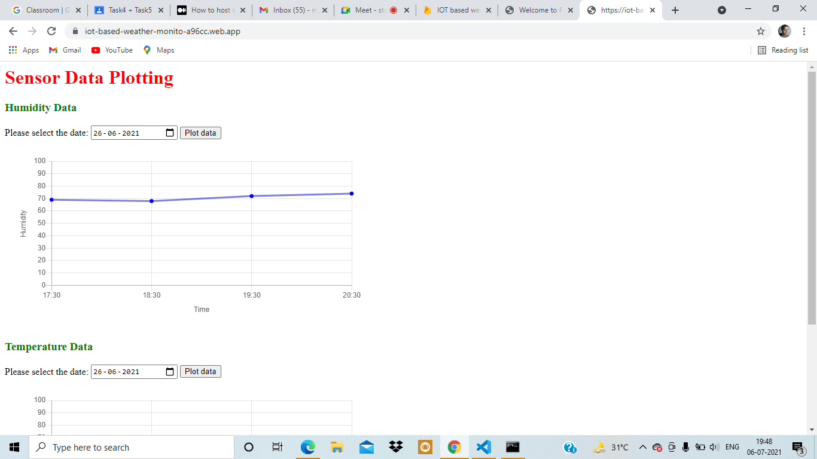

Screenshot of designed Webapp

Advantages:

* Easy to install
* Accurate sensing of air quality and humidity
* Easy to plot data

Challenges:

* Few more sensors can be added

Applications:

* Industrial vicinity air quality checking
* Humidity measurement in different types of areas
* Temperature measurement

Learning outcomes:

* Arduino
* Html coding
* JavaScript

Conclusions: IoT based weather monitoring system uses microcontroller to improve air quality.

References:

* Google
* YouTube
* <https://medium.com/@aleemuddin13/how-to-host-static-website-on-firebase-hosting-for-free-9de8917bebf2>
* HTML- https://www.w3schools.com/html/html_basic.asp

CSS- https://www.w3schools.com/css/css_intro.asp

Bootstrap- https://www.tutorialspoint.com/bootstrap/index.htm

JavaScript- https://www.w3schools.com/js/

HTML Requests in JavaScript-

https://www.freecodecamp.org/news/here-is-the-most-popular-ways-to-make-an-http-r

equest-in-javascript-954ce8c95aaa/

Appendix:

* Source code (Webapp): https://github.com/Tinkerers-Lab-VESIT-ETRX/IoT-based-Weather-monitoring-7/commit/e98ef9f5b546373b9fa365e29d29b32ec7d7609a
* Source code (Arduino code): <https://github.com/Tinkerers-Lab-VESIT-ETRX/IoT-based-Weather-monitoring-7/commit/ed343bcf3e72aeef96acd130696db13de9b67abf>